CHANGE HARDWARE COMPATIBILITY OF A VM (EITHER BY CLONE/CREATE NEW ONE) WHICH IS ALREADY CREATED AND CONFIGURED.

PROCEDURE:

STEP 1: GOTO VM WARE WORKSTATION.

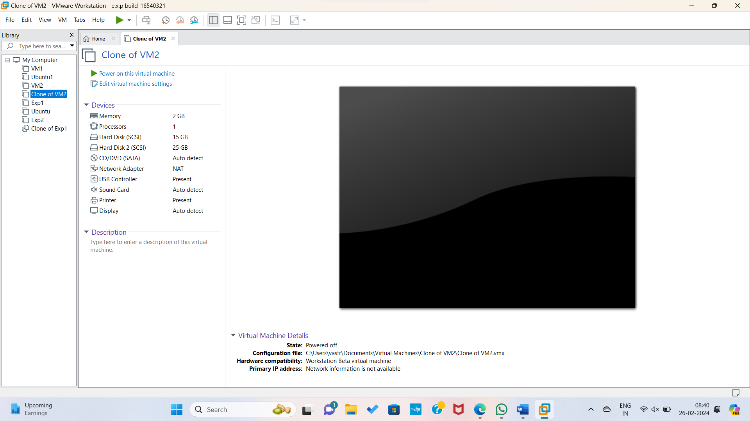

STEP2: RIGHT CLICK THE VM AND GOTO THE SETTINGS.

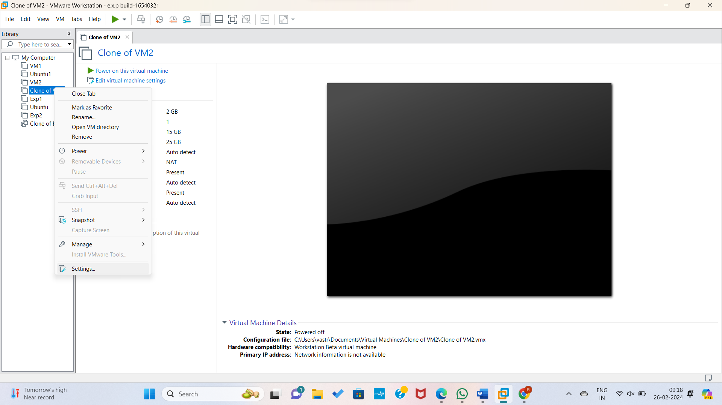

STEP 3: ADD HARDWARE WIZARD AND SELECT SCSI AND CLICK NEXT.

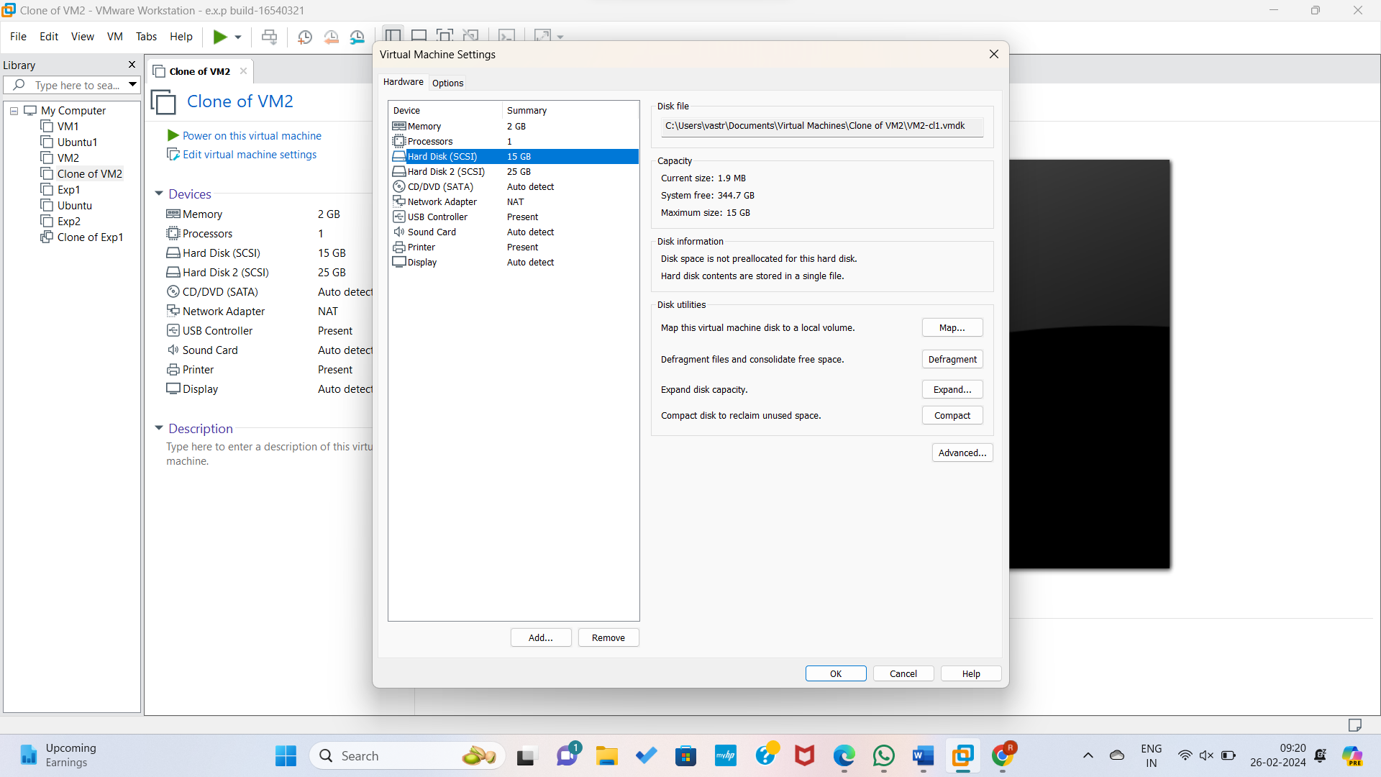

STEP 4: CREATE NEW VIRTUAL DISK.

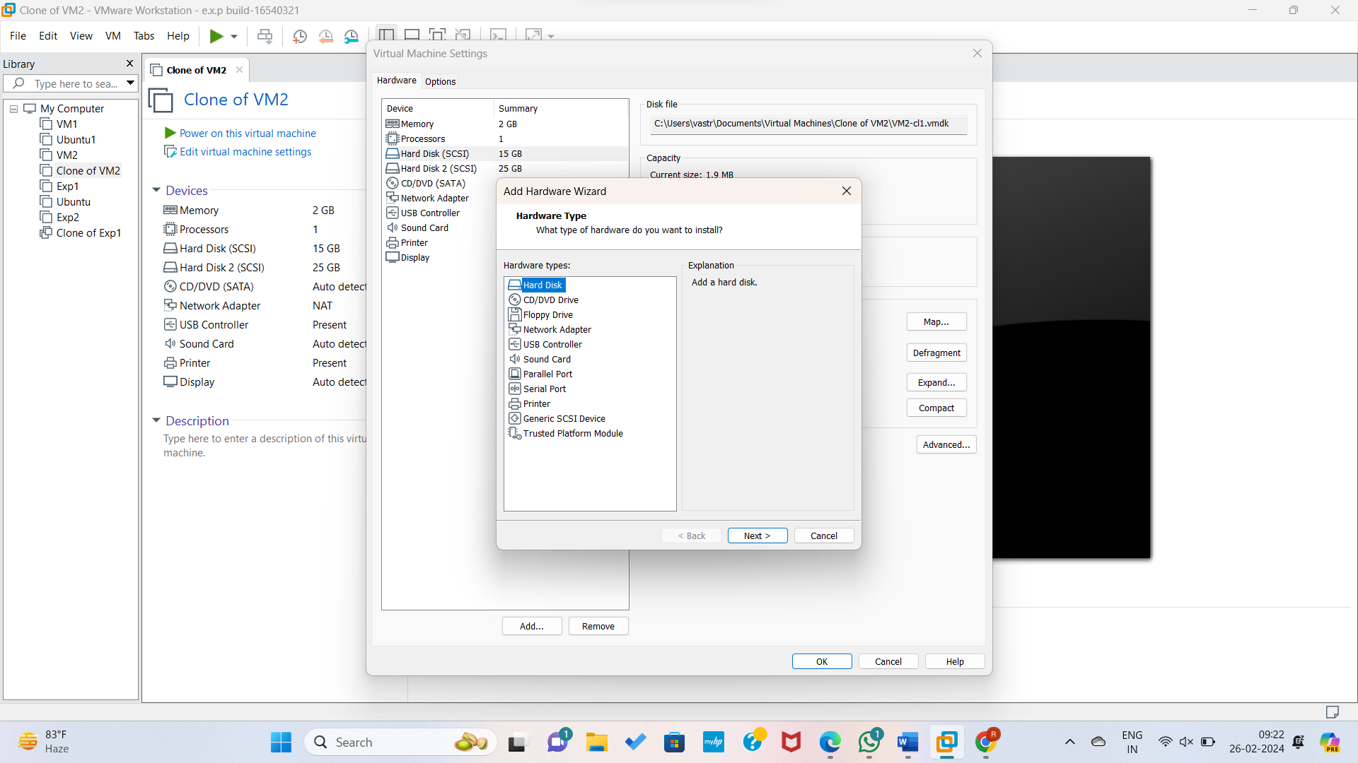

STEP 5: SELCT THE DISK SIZE AS 2.0. AND SELCT SPLIT VIRTUAL DISK INTO MULTIFILES.

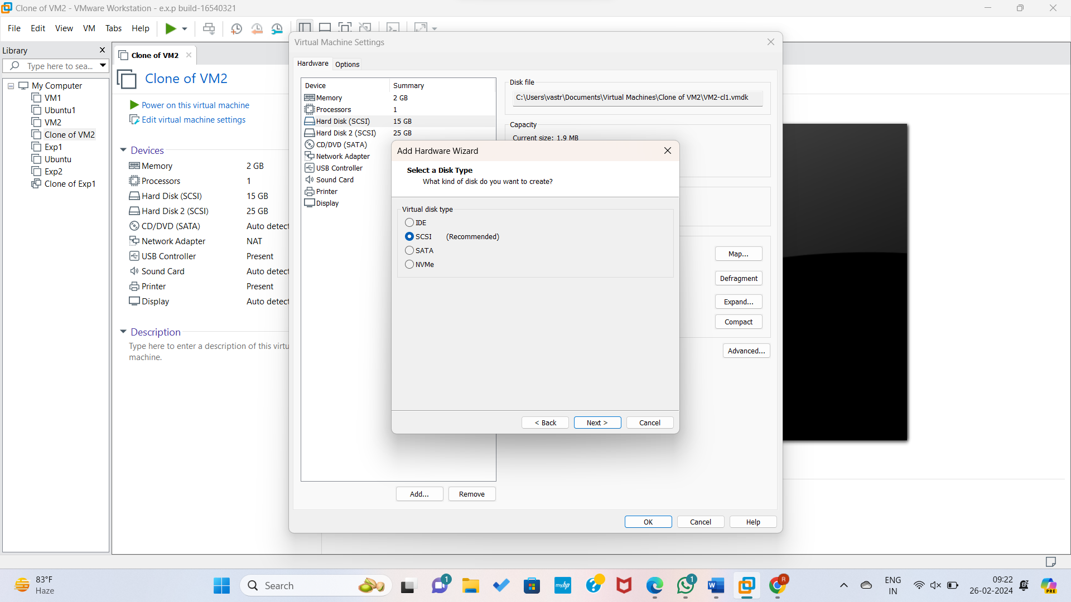

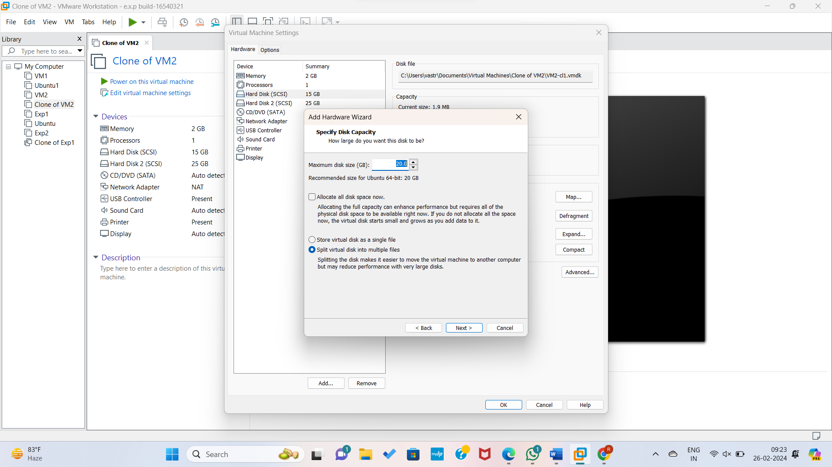

STEP 6: GIVE NAME AND CLICK THE FINISH.

